Front-end Developer

We are looking for a highly qualified Front-end developer who will join our IT team. You should have motivated to combine the art of design with the art of programming. You will be responsible for building client-side web components. You should be able to understand our customer needs into functional and appealing interactive applications.
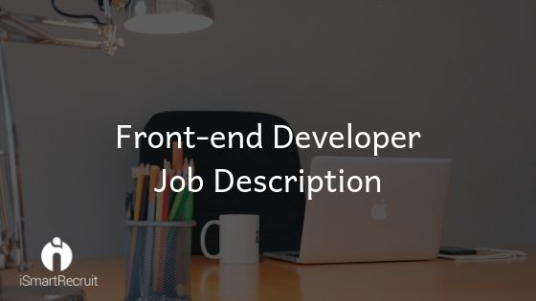

As a front-end, you should be able to translate the UI/UX design wireframes to actual code that will produce visual elements of the application. You will work with the UI/UX designer as well as a backend developer and bridge the gap between graphical design and technical implementation, taking an active role on both sides and defining how the application looks as well as how it works and ensuring that high performance on every platform.
Responsibilities
- Delivering high quality and a complete front end application with responsive design.
- Build reusable code and libraries for future use.
- Ensuring high performance on mobile and desktop.
- Writing tested, idiomatic, and documented JavaScript, HTML and CSS code.
- Ensure the technical feasibility of UI/UX designs.
- Coordinate with the back-end developers in the process of building the RESTful API.
- Coordinating the workflow between the graphic designer and backend developer.
- Communicating with external web services.
- Create quality prototypes for much clear understanding.
- Stay up-to-date with new emerging technologies like graphQL, Vue js. Etc...

Requirements
- Good hands-on web markup, including HTML5, CSS3.
- Basic understanding of server-side CSS pre-processing platforms, like LESS and SASS.
- Knowledge of SQL/NoSQL will be an advantage.
- Should be able to build appropriate unit tests & Integration test.
- Strong Logical Thinking as well as creative thinking.
- Good understanding of advanced JavaScript libraries and frameworks, such as AngularJS, VueJS, BackboneJS, DurandalJS, ReactJS, etc.
- Knowledge of basic SEO principles.
- Proficient understanding of code versioning tools such as SubVersion, GitHub.
- Knowledge of how to interact with RESTful APIs and formats such as JSON, XML.

Looking for Front End Developer?

Promote your Front End Developer job advertisement to 15+ free job boards and social media with a click.

Schedule a free personalised demo and start to post your ad today.

