PHP Developer Job Description Template

We are looking for a creative and autonomous person who likes challenges and works well in an independent environment and also within a professional team. If you want to deliver end-to-end applications workflow and be involved in all phases of the software development lifecycle, here’s you get chance!

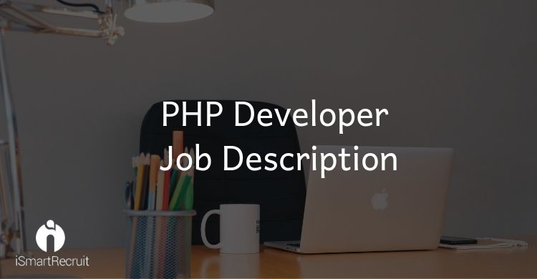

You should have motivated, flexible, able to adapt to a new environment and able to efficiently communicate with certain customers as well as other development team members to find new ways for improvement for software lifecycle.
You will be a part of our creative team that is responsible for all aspects of the ongoing software development from the initial specification, through to developing, testing and deployment.
Responsibilities
- Design and develop features and modules for enterprise applications.
- Write a well maintainable and efficient code which easy to unit test.
- Ensure designs comply with code specifications.
- Prepare software components which use in future.
- Support the team continuous improvement by reviewing alternatives and technologies and presenting these for architectural review and optimization of the application (also ensure database optimization and performance).
- Ensure data security and application maintenance.
- Coordinate with the front-end developers in the process of building web components.
- Integrate with external web services like social media APIs, Google APIs etc.
- Comprehend industry best practices.
Requirements
- BE/ME or BS/MS degree in Computer Science, Engineering or a related subject degree is allowed.
- You must have 1+ years of hands-on experience on object-oriented PHP programming concepts.
- Stay up-to-date with new emerging technologies like Laravel, Phalcon, Fuel PHP, Slim, graphQL also web technologies like HTML, CSS, Javascript, AJAX, jQuery etc..
- Understanding of open source projects like WordPress, BuddyPress, osCommerce, Joomla, Drupal, Wikis, SocialEngine etc.
- Experience in well-known third-party APIs ( Facebook, Google, Amazon Twitter etc).
- Aware of SQL and NoSQL databases and their declarative query languages.
- Proficient knowledge of code versioning tools, such as GitHub, SubSVN, GitLab etc.

Looking for PHP Developer?

Promote your PHP Developer job advertisement to 15+ free job boards and social media with a click.

Schedule a free personalised demo and start to post your ad today.

