Recruiting Coordinator Job Description Template
Recruiting Coordinator job description template can be used for posting on online job boards or career pages and you can customize it easily for your company. It includes important details like Recruiting Coordinator's duties and responsibilities.
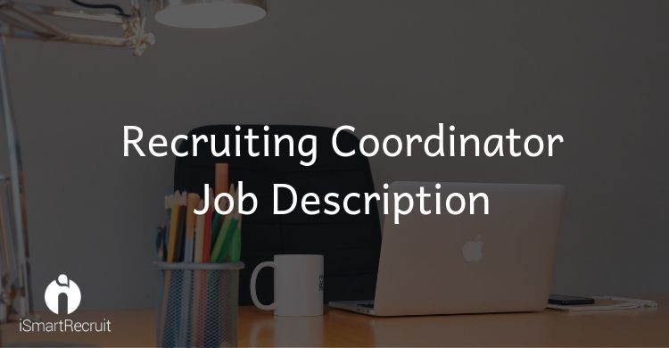
Recruiting Coordinator Job Profile
The Recruiting Coordinators are responsible for the hiring process from the start to the end. They are to fill the open positions by attracting the best candidates and hiring employees that add value to the company.
Recruiting Coordinator Job Description
We are looking for a qualified Recruiting Coordinator to be a part of our company. Your role as a Recruiting Coordinator will require you to assist with finding, sourcing, attracting and hiring talent and stay motivated during the whole process.
Recruiting Coordinator Duties and Responsibilities
Your key duties and responsibilities as a Recruiting Coordinator would be:
- To develop recruitment goals and objectives
- Develop a sustainable recruiting strategy based on our goals and needs
- Source passive candidates
- Search resume database for the fittest candidates
- Communicate with Hiring Managers
- Determine the effectiveness and success of current recruiting plans and strategies
- Find qualified active and passive candidates by building talent networks
- Use a multi-channel approach to recruit
- Identify key recruiting KPIs
- Build a Recruitment Marketing and Employer Branding strategy to attract high-quality applicants
- Choose the right candidates by reviewing applicants to evaluate if they meet the position requirements
- Adhere to laws, rules and regulations
- Adhere to personal data privacy regulations
- Prepare a report on a weekly basis for the tasks completed or in progress
Recruiting Coordinator Requirements and Qualification
- Work experience of (x) years as a Recruiting Coordinator or similar role in HR.
- Ability and willingness to learn about the position requirements
- Passion about HR methods
- Ability to scan large volumes of resumes.
- Experience in Employer Branding methods
- Understanding and familiarity with Recruitment Marketing
- Good understanding and experience with HR tools such as ATS and HRIS
- Some understanding of basic marketing strategies
- l thinker and problem-solving skills
- Team player
- Good time-management skills
- Great interpersonal and communication skills
- Degree in Business Administration or relevant field
How much a Recruiting Coordinator can get in the US?

According to PayScale - a recruiting coordinator can make approx $42,858 if you are having less than 1 year of experience. It can be increased to $58,545 according to your experiences like 20 years or more than that!!!
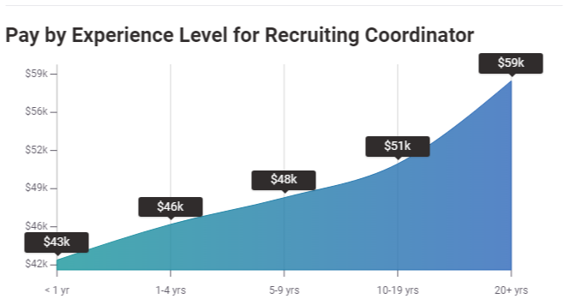
Source: PayScale
How much a Recruiting Coordinator can get in the UK?

If you go for the United Kingdom, According to them a recruiting coordinator can earn £19,829 in their early career with less than or 1 year of experience. It can be increased to £23,984 according to their experience up to 20 years or more and expertise.
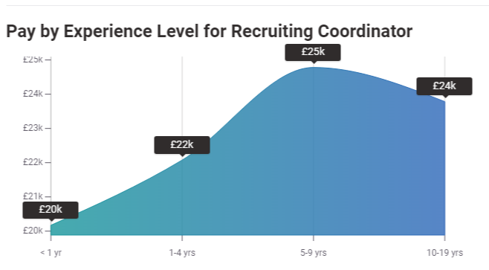
Source: PayScale
How much a Recruiting Coordinator can get in Germany?

Here is another dynamics from PayScale. A recruiting coordinator can make up to €40,775 if he has less than 1 year of experience in this field. It can be increased by the time to €75,000 if a person is having more than 20 years of experience in the same field.

Looking for Recruiting Coordinator?

Promote your Recruiting Coordinator job advertisement to 15+ free job boards and social media with a click.

Schedule a free personalised demo and start to post your ad today.

