Senior Java Developer

Senior Java Developer job description template can be used for posting on online job boards or career pages and you can customize it easily for your company. It includes important details like Java Developer's duties and responsibilities.
Java Developer responsibilities include
- To interact with the customer and internal teams in Identifying and analyzing requirements for development purposes.
- To perform activities related to the creation of documents for client requirements.
- Prioritizing the task and executing tasks throughout the SDLC.
- Provide technical help to junior developers.
Job brief
We are looking for a Senior Java Developer to manage the SDLC, from planning and prioritizing to testing and rapid delivery.
You will be part of our talented software development team that works on mission-critical applications. As a Senior Java developer roles, you are responsible for designing, developing include maintaining Java/Java EE application while providing your expertise in the development lifecycle.

Responsibilities
- Senior Java developers need to analyze and assess a client’s needs to find the most suitable solution for them, so strong analytical and problem-solving skills are vital for this role.

- Senior Java Developer responsibilities include gathering system requirements, building application specification document, draw flow charts, design application architecture and implement modernizes application design and testing features before release.

- You should have hands-on experience in developing software with agile or scrum methodologies and are ready to lead our junior developer’s team.

- You should have a creative mindset to think outside the box and find alternative ways to develop computer systems.

- Ensure our applications must be secure and up-to-date.

Requirements
- You should have experience with Object-Oriented Design.
- At least 5 years of work experience as a Senior Java Developer or any similar role.
- In-depth knowledge of popular Java frameworks like Struts, Play, JSF and Spring MVC.
- Positive and professional approach at all times.
- Familiar with SQL or NoSQL Database like MySQL, MongoDB.
- Experience with the large and disparate data set.
- Creating Web Services and RESTful services with Web API.
- Familiar with Open Source tools and good to have experience with Amazon Web Service (AWS).

How much a Senior Java Developer can get in the US?

According to PayScale - a senior java developer can make approx $88,058 in their early career with 1-4 years of experience. It can be increased to $114,672 according to your experiences like 20 years or more than that!!!
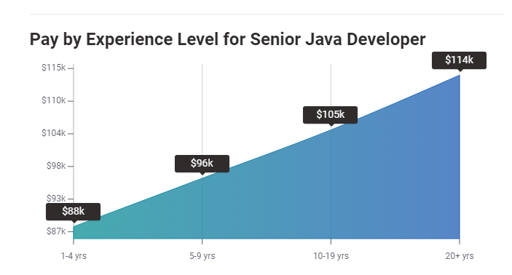
Source: PayScale

How much a Senior Java Developer can get in the UK?

PayScale reveals everything you need to know about the salary in different countries. According to them, a senior java developer can earn £52,273 in their early career with 1-4 years of experience. It can be increased to £50,797 according to their experience up to 20 years or more and expertise. 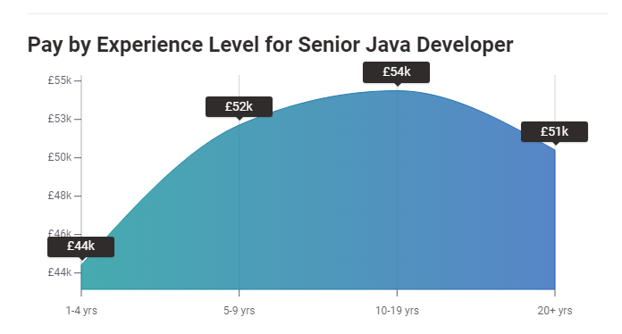
Source: PayScale

How much a Senior Java Developer can get in Germany?

Here is another dynamics from PayScale. A senior java developer can make up to €57,656 if he has 1 to 4 years of experience in this field. It can be increased by the time to €66,500 if a person is having more than 20 years of experience in the same field.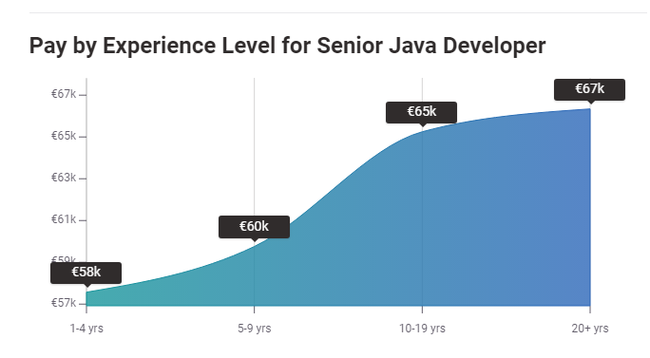 Source: PayScale

Looking for Senior Java Developer?

Promote your Senior Java Developer job advertisement to 15+ free job boards and social media with a click.

Schedule a free personalised demo and start to post your ad today.

