Supply Chain Manager Job Description Template
Supply Chain Manager job description template can be used for posting on online job boards or career pages and you can customize it easily for your company. It includes important details like Supply Chain Manager's duties and responsibilities.
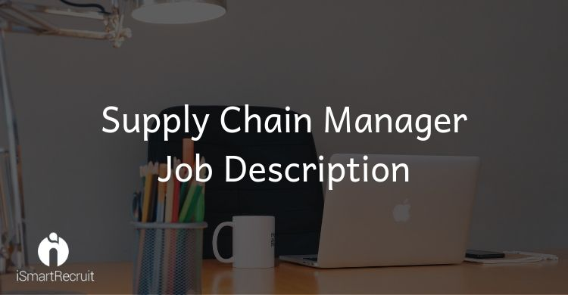
Supply Chain Manager Job Profile
The Supply Chain Managers has to manage and oversee the company's overall supply chain and logistics strategy and operations to maximize process efficiency and productivity. They also play an important role in developing and maintaining good relationships with vendors and distributors.
Supply Chain Manager Job Description
We are looking for a zestful and experienced Supply Chain Manager to be a part of our company. Your role as a Supply Chain Manager will be to plan, implement and monitor our overall supply chain strategy and to maximize efficiency and productivity.
Supply Chain Manager Duties and Responsibilities
Your key duties and responsibilities as a Supply Chain Manager would be:
- To plan and implement the overall supply chain strategy
- Collaborate with Sales, Operations, and Customer Service teams
- Determine key supply chain KPIs
- Suggest solutions for process improvements
- Identify process bottleneck and implement solutions in a timely manner
- Train and evaluate others
- Provide constructive feedback
- Work with finance, sales, and manufacturing team to determine the best vendors and distributors
- Build and maintain good relationships with vendors
Supply Chain Manager Requirements and Qualification
- Work experience of (x) years as a Supply Chain Manager.
- Explicit experience with supply chain management software (such as SAP MM, AP Modules, SAP Plant Maintenance, etc.)
- Critical thinker and problem-solving skills
- Team player
- Good time-management skills
- Great interpersonal and communication skills
How much a Supply Chain Manager can get in the US?

According to PayScale - a supply chain manager can make approx $58,649 if you are having less than 1 year of experience. It can be increased to $89,957 according to your experiences like 20 years or more than that!!!
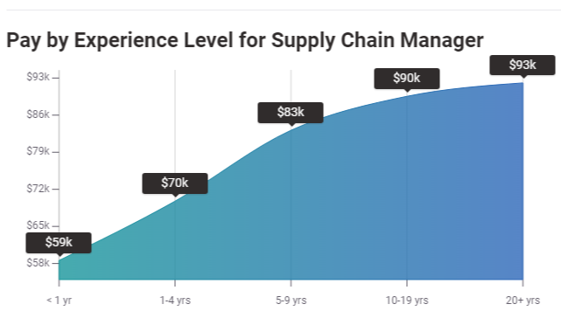
Source: PayScale

How much a Supply Chain Manager can get in the UK?

If you go for the United Kingdom economy, According to them a supply chain manager can earn £27,363 in their early career with less than or 1 year of experience. It can be increased to £44,589 according to their experience up to 20 years or more and expertise.

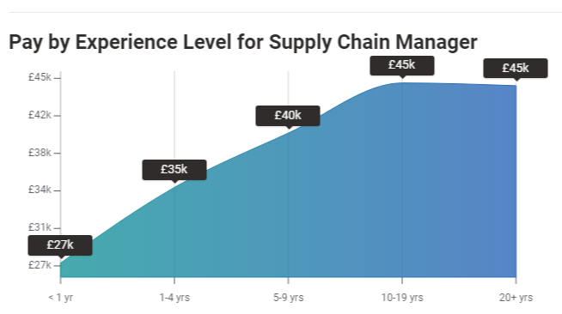
Source: PayScale

How much a Supply Chain Manager can get in Germany?

Here is another dynamics from PayScale. A Supply Chain Manager can make up to €48,414 if he has less than 1 year of experience in this field. It can be increased by the time to €82,500 if a person is having more than 20 years of experience in the same field.
To read similar job templates you can refer our blog section.

Looking for Supply Chain Manager?
Promote your Supply Chain Manager job advertisement to 15+ free job boards and social media with a click.

Schedule a free personalised demo and start to post your ad today.

