Team Leader Job Description Template
Team Leader job description template can be used for posting on online job boards or career pages and you can customize it easily for your company. It includes important details like Team Leader's duties and responsibilities.
Team Leader Job Profile
Team Leaders plays an important role by creating an open and motivated environment among the team members to attain company goals. They communicate, delegate tasks and deadlines for their teams.
Team Leader Job Description
We are looking for a qualified Team Leader to be a part of our company. Your role as a Team Leader will be to supervise, oversee and manage your team members and also keep them motivated to achieve the company goals.
Team Leader Duties and Responsibilities
Your key duties and responsibilities as a Team Leader would be:
- To set clear team goals and KPIs
- Delegate tasks and set project deadlines
- Oversee day-to-day teams' operation and performance
- Do regular performance evaluation
- Create a healthy and motivating work environment and atmosphere
- Develop a well designed and motivating evaluation program
- Communicate with teams about their performance
- Monitor team performance and report on metrics
- Motivate team members
- Discover training needs and provide coaching
- Get feedback from team members and resolve any issues or conflicts
- Plan and organize team-building activities
Team Leader Requirements and Qualification
- Work experience of (x) years as a Team Leader.
- Good PC skills, especially MS Excel
- In-depth knowledge of performance metrics
- Critical thinker and problem-solving skills
- Team player
- Good time-management skills
- Great interpersonal and communication skills
Degree in Management or training in team leading is a bonus

How much a Team Leader can get in the US?

According to PayScale - a senior java developer can make approx $60,381 in their early career with less than 1 year of experience. It can be increased to $101,647 according to your experiences like 20 years or more than that!!!
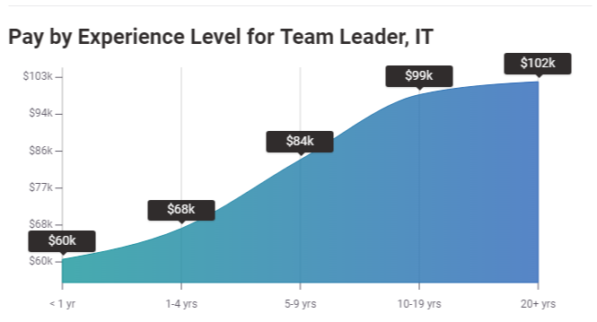
Source: PayScale

How much a Team Leader can get in the UK?

PayScale reveals everything you need to know about the salary in different countries. According to them, a Team Leader can earn £30,220 in their early career with 1-4 years of experience. It can be increased to £43,442 according to their experience up to 20 years or more and expertise.
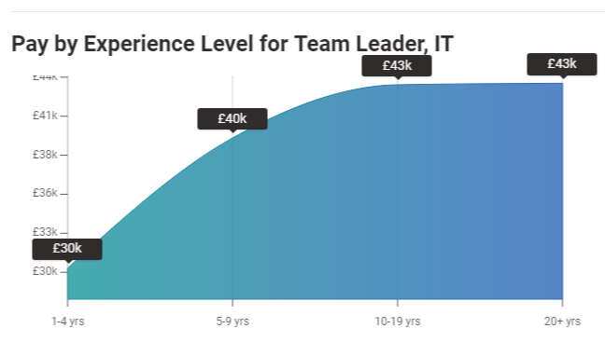
Source: PayScale

How much a Team Leader can get in Germany?

Here is another dynamics from PayScale. A team leader can make up to €57,937 if he has 1 to 4 years of experience in this field. It can be increased by the time to €82,500 if a person is having more than 20 years of experience in the same field.
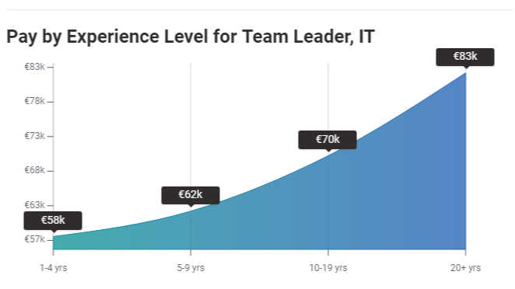
Source: PayScale

Looking for Team Leader?

Promote your Team Leader job advertisement to 15+ free job boards and social media with a click.

Schedule a free personalised demo and start to post your ad today.

