Warehouse Associate Job Description Template
Warehouse Associate job description template can be used for posting on online job boards or career pages and you can customize it easily for your company. It includes important details like Warehouse Associate's duties and responsibilities.
Warehouse Associate Job Profile
The Warehouse Associates have to be organised as they are associated with duties like receiving and processing incoming stocks and managing inventories in the warehouse.
Warehouse Associate Job Description
We are looking for a hardworking and capable Warehouse Associate to be a part of our company. Your role as a Warehouse Associate will be to receive, input, sort, load and unload materials and to perform other warehouse activities.
Warehouse Associate Duties and Responsibilities
Your key duties and responsibilities as a Warehouse Associate would be:
- To welcome delivery trucks
- Receive and track shipments
- Embark merchandise in delivery trucks using appropriate tools
- Accommodate and carefully handle fragile merchandise
- Track and maintain a report about the shipment arrival and departure times
- Tag and label merchandise
- Organize the merchandise by labelling them according to size, shape, and type.
- Pack the merchandise in accordance with relevant procedures and standards
- Prepare all orders for shipment
- Make a record and manage all impaired or damaged merchandise items
- Operate adequate merchandise management tools (for example, forklift)
- Enter data in inventory and logistics software programs
Warehouse Associate Requirements and Qualification
- Work experience of (x) years as a Warehouse Associate.
- Valid Driver's License
- Forklift Operation Certification will be considered an advantage
- Explicit experience with inventory and logistics software programs
- Great physical stamina and manual dexterity
- Team player
- Good organizational and time-management skills
- Great interpersonal and communication skills
- Problem solver
How much a Warehouse Associate can get in the US?
According to PayScale - a warehouse associate can make approx $12.35 per hour in their early career with less than 1 year of experience. It can be increased to $15 per hour according to your experiences like 20 years or more than that!!!
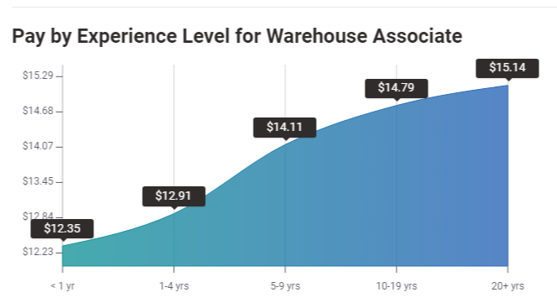
Source: PayScale
How much a Warehouse Associate can get in the UK?
PayScale reveals everything you need to know about the salary in different countries. According to them, a warehouse associate can earn £8.27 per hour in their early career with less than 1 year of experience. It can be increased to £8.85 per hour according to their experience up to 20 years or more and expertise.
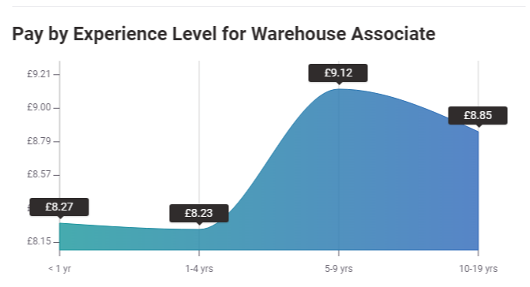
Source: PayScale
Looking to Promote Warehouse Associate?
Promote your Warehouse Associate job advertisement to 15+ free job boards and social media with a click.
Schedule a free personalised demo and start to post your ad today.

